The Sum of All Media: The World Flaw Approach in 360° Narrative Design
by Kurt McClung and Stephanie McClung
"METHODOLOGICAL CONTRIBUTION
The World Flaw Approach
An original framework for narrative and world design based on the premise that the defining flaw of a fictional world determines its conflicts, themes, cultures, dramatic structures, and opportunities for transmedia expansion. Core principles include:
• Systems thinking and world logic
• Thematic architecture
• Narrative ecosystems
• Metaphorical environments
• Intellectual property scalability
The methodology has been applied professionally across videogames, television, cinema, graphic novels, roleplaying games, and immersive experiences."
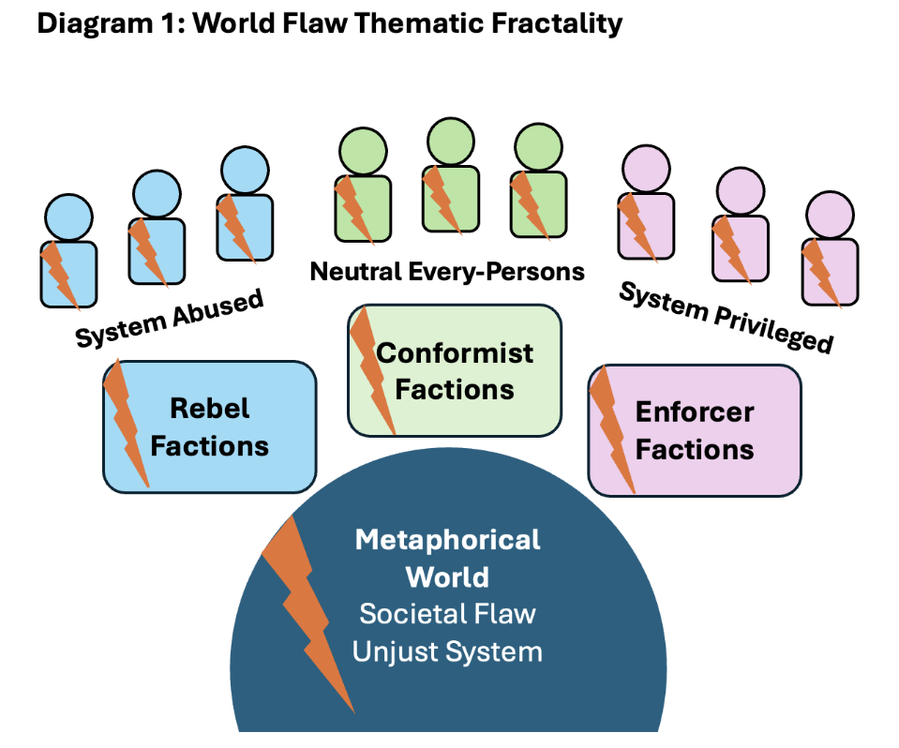
Participants will also have the opportunity to take part in an optional research evaluation of a transmedia project, exploring how the same digital character is perceived through movement across animation, computer game, and real-time performance.
"KURT MCCLUNG
Writer • Narrative Designer • Transmedia Strategist • Educator
PROFESSIONAL PROFILE
Kurt McClung is a writer, narrative designer, and transmedia strategist with more than three
decades of experience across videogames, film, television, graphic novels, tabletop games, and interactive media. He has contributed to over one hundred fictional worlds for more than fifty studios and publishers in Europe, North America, and Asia.
Drawing upon an Industrial Engineering education from Purdue University, he approaches
storytelling as a system of interconnected structures, themes, and experiences. This interdisciplinary perspective led him to develop the World Flaw Approach, an original methodology for 360° narrative design and transmedia worldbuilding.
His work combines practical industry leadership with academic and professional teaching,
focusing on fictional ecosystems, thematic architecture, interactive storytelling, and scalable intellectual property creation.
"
"Stephanie McClung
Dramaturg · Narrative Designer · Executive Producer
Founder of Ad Hack Content Development & Production
Fréjus, France
Profile
As a dramaturg, narrative designer, and executive producer, I develop stories for video games, film, theatre, and television.
I support projects from the earliest concept stage through narrative structure and character
development, worldbuilding, adaptations, and transmedia development. I also contribute to the preparation of creative and funding proposals.
As the founder of a content production studio, I collaborate with international teams of writers, directors, game designers, and producers. My background in theatre strongly informs my approach to pacing, character development, and audience engagement."

